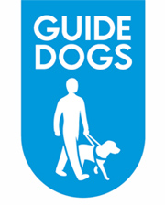

Pat on the Back Nomination Form

Once completed please email this form to: Your local team

Here's where you can tell us about a person or team that you'd like us to consider for a Pat on the Back. Please note fields marked with an asterisk * are mandatory.
1 Name of nominator: *
2 Address of nominator: *
3 Phone number:
4 Email:
5 From the list of Award categories select the award:
A Open
B Passionate
C Innovative

Type A, B, C, here:*
6 Name and contact details of person or team you are nominating:*
7. Team where the volunteer or staff member volunteers/works: (if known)
8 Is the nominated person aged under 25? Yes / No
9 Please tell us (in no more than 500 words) why you have nominated the person or team for this category:*

Refer to Guide Dogs values to evidence your nomination Local Awards web page

Marketing, publicity and media
We will use your personal information to process your nomination and to communicate with you about the award.
Those shortlisted for a local award will be asked to have their photographs taken and/or be filmed for publicity purposes.

If you require assistance in completing the form, or alternative formats please call: Your local team
End of document.

